1. Download FFMPEG to the PC you are going to stream From.
   1. <https://ffmpeg.zeranoe.com/builds/>
2. After you download the FFMPEG Extract the folder to an easy location to access on the computer. (I just use Desktop)
3. Open the FFMPEG Directory/Folder
   1. 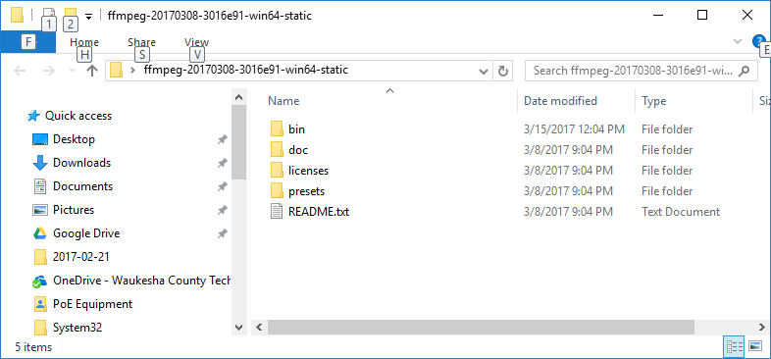
   2. Open the Bin Directory
   3. 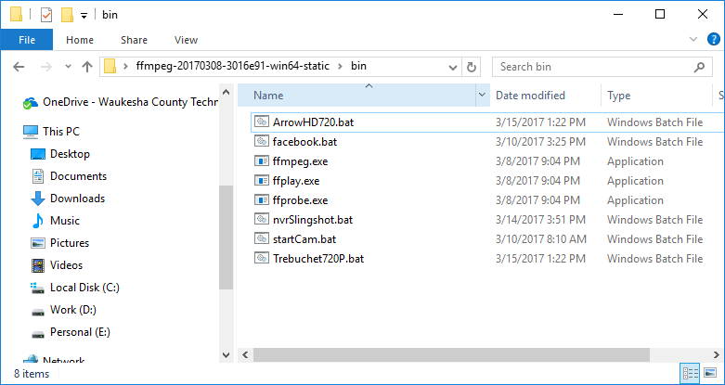
   4. Inside of the Bin Directory you Need to create the Batch File to grab the RTSP stream and convert it to RTMP for youtube.
   5. Once you create your batch file, you need to put in the information for the camera and the stream.
      1. ffmpeg -f lavfi -i anullsrc -rtsp_transport tcp -i rtsp://**CAMERAUSER**:**CAMERAPASS**@**CAMERAIP**:**RTSPPORT**/streaming/channels/**1** -tune zerolatency -vcodec libx264 -pix_fmt + -c:v copy -c:a aac -strict experimental -f flv rtmp://a.rtmp.youtube.com/live2/**YOU-TUBE-KEY**
      2. The Credentials you will need to fill in are the Following
         1. Cam user: usually **admin** unless you have something else
         2. Camera Password: default is **12345**
         3. Camera IP : The **IP address** of the camera
         4. RTSP Port: The streaming port on the camera – Deafult is **554**
         5. Stream Type: 1= Main Stream 2= Substream
         6. You Tube Live Stream Key can be found at your you tube account at the live dashboard https://www.youtube.com/live_dashboard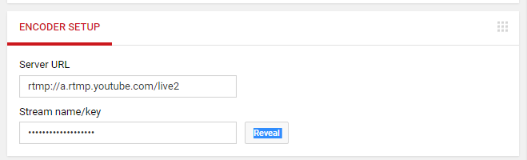
      3. So putting that all together gives us the RTSP information we need to give ffmpeg
         1. Main Stream Resolution: Rtsp://admin:12345@192.168.1.212:554/streaming/channels/1
         2. Sub Stream Resolution: Rtsp://admin:12345@192.168.1.212:554/streaming/channels/2
      4. Save the Batch File and test if we used the above information the batch file would look like this: ffmpeg -f lavfi -i anullsrc -rtsp_transport tcp -i rtsp://admin:arcdyn123@192.168.1.212:554/streaming/channels/1 -tune zerolatency -vcodec libx264 -pix_fmt + -c:v copy -c:a aac -strict experimental -f flv rtmp://a.rtmp.youtube.com/live2/YOUR_YOU_TUBE_KEY
      5. The Camera bandwidth is determined at the camera and not ffmpeg, so if you don’t have enough bandwidth adjust your cameras bitrate per your upload speed.
      6. Here is the facebook Batch file: ffmpeg -f lavfi -i anullsrc -rtsp_transport tcp -i rtsp://admin:12345@192.168.1.211:554/streaming/channels/01 -tune zerolatency -vcodec libx264 -pix_fmt + -c:v copy -c:a aac -strict experimental -f flv "rtmp://rtmp-api.facebook.com:80/rtmp/FACEBOOK-KEY"